Coffee Bean Classification Using Deep Learning

Jobin T J  
Department of Computer Applications  
Amal Jyothi College Of Engineering Kanjirappally, India  *tjjobin@amaljyothi.ac.in*

Aleena Thomas  
Department of Computer Applications  
Amal Jyothi College Of Engineering Kanjirappally, India *aleenathomas2024@mca.ajce.in*

*Abstract*—Coffee bean classification, an integral process in the coffee industry, has traditionally relied on manual methods.This study uses deep learning and computer vision techniques to classify coffee beans in a novel way. The model makes use of transfer learning and a ResNet50-based architecture that has been adjusted for the differentiation of coffee beans according to their visual characteristics.Approach is equipped with data augmentation and re-scaling, contributing to improved generalization and model robustness.

**The study includes the creation and assessment of a strong classification model capable of identifying the different characteristics of post-roasted coffee beans, attaining a remarkable accuracy rate of 97% . Extensive testing shows how well the model recognizes the visual properties of coffee beans.**

Keywords — C***offee Bean Grading***, ***Image Processing, ResNet50, Transfer Learning, Dataset, Training.***

# Introduction

The complex procedure of roasting coffee beans is closely related to the coffee business, an important worldwide economic power and the producer of one of the most cherished beverages in the world. The degree of roasting, a crucial factor influenced by the artful process of roasting, plays a fundamental role in determining the flavor and quality of brewed coffee. Traditionally, manual methods and human judgment have been employed to assess the attributes of coffee beans.

The coffee business is on the verge of transformation in today's age of technological advancement, where automation offers precision and efficiency. ResNet model-based deep learning and computer vision techniques present a compelling way to improve coffee bean classification and quality management.

Before roasting, green coffee beans exhibit a soft texture and emit a 'grassy' aroma. Roasting initiates chemical transformations at high temperatures. Once green coffee beans reach their maximum temperature, they undergo a cooling process to halt roasting [1]. Roasting leads to weight reduction, introduces new aromas, and prepares the beans for brewing . The color of roasted coffee beans serves as a key descriptor [2]. Lightly roasted beans are noted for their high acidity and caffeine content, medium roasted is darker brown.

In this study, the objective is to classify roasted coffee beans based on their roast levels using the ResNet model, a powerful deep learning architecture celebrated for its excellence in image classification. The application of ResNet enables precise and automated categorization of coffee beans according to their roast characteristics, promising significant advancements in quality control within the coffee industry.

# LITERATURE REVIEW

## Coffee bean classification has traditionally relied on manual inspection, a labor-intensive process. Recent advancements in deep learning have opened up opportunities for automating this task, improving both efficiency and accuracy. Here are some few significant investigations into the classification of coffee beans using deep learning:

The deep learning model proposed by Zhang et al. can be used to classify coffee beans based on the presence or absence of defects. This can be done by training the model on a dataset of coffee bean images labeled with the type of defect . Once the model is trained, it can be used to classify new coffee bean images into different defect categories[3].

Chang et al. applied deep learning to detect coffee bean defects according to standards defined by the Specialty Coffee Association (SCA). Their deep learning model demonstrates the capability to identify various defect types, contributing to the quality control of coffee beans [4].

A recent review in the field of coffee bean quality assessment using images highlighted various machine learning methods that are employed to classify coffee beans based on their quality characteristics.This survey offers insights into the different methodologies employed in this context [5].

In a recent study, Deep learning and image processing techniques to identify the roast levels of coffee beans.Nasution et al. introduced a method that achieved an impressive 97.5% accuracy in the identification of different roast levels in coffee beans. [6].

In a research conducted by MA Alrasyid in 2023, they employed pre-trained Convolutional Neural Networks (CNNs) with ResNet-50 architecture to classify three distinct varieties of Indonesian Arabica coffee beans. This study exemplified the utilization of deep learning for the categorization of coffee beans[7].

The research paper "Review On Image-based Coffee Bean Quality Classification" authored by SP Pragathi in 2022 offers a comprehensive look at different machine learning methods utilized for categorizing coffee beans according to their quality [8].

In conclusion, using deep learning and machine learning has greatly improved the way we inspect coffee beans. The sources we discussed in this review show that these technologies make the process of inspecting coffee beans more accurate and efficient, which is a big step forward.

This paper builds upon these findings by introducing a new method that includes ResNet50 for categorizing coffee beans, adding to the continuously evolving agricultural technology field.

# METHODOLOGY

The methodology for coffee bean classification using

the ResNet algorithm involves the following steps:

## **Data Collection**

## To start the research, gather a diverse and comprehensive dataset of coffee bean images. This dataset should encompass a variety of coffee bean types, including different species (e.g., Arabica, Robusta), quality levels, and roast types (light, medium, dark, green). The images can be collected from various sources, such as coffee farms, online databases, or coffee industry partners.

## **Data Preprocessing**

Preprocess the collected images to a uniform size, often set at 224x224 pixels. Standardizing image dimensions is crucial for compatibilty with deep learning models.Normalize pixel values to a consistent scale, typically within the range of [0, 1]. Normalization enhances training efficiency and mitigates issues stemming from variations in pixel intensity. In figure you can see the result of preprocessed image.

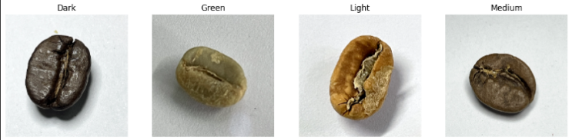

Fig. 1

## **Transfer Learning**

Use transfer learning to fine-tune a pre-trained ResNet50V2 model on the preprocessed images.Transfer learning is taking a model that has already been trained and updating the final layers to match the new data in order to adapt it to a new task. This process reduces training time and increases the model's precision.

## **Model Training**

The entire model, including the pre-trained ResNet50 V2 layers and the custom classification layers, will be trained using the coffee bean dataset. This process allows the model to fine-tune its parameters to the coffee bean images.

## **Model Evaluation**

Use a validation dataset different from the training dataset to assess the performance of the trained ResNet50 model.The assessment of the model's performance involves measuring several metrics like accuracy, precision, recall, and F1 score.

Overall, this methodology provides a well-structured framework for building and assessing a deep learning model for coffee bean image classification. The results from the model evaluation will shed light on the model's performance, highlighting its strengths and potential areas for further improvement or research.

# BUILD MODEL

### The effective grading of coffee beans using image processing techniques depends on the development of a trustworthy and precise machine learning model. In this seminar article, provide a ResNet-based approach for coffee bean grading that makes use of an advanced convolutional neural network's capabilities.

1. **Importing Libraries**

Pandas, Numpy, and other machine learning libraries are described as an interface of a set of rules created in a specific language to carry out repetitive tasks like arithmetic calculations, interpreting images, and so forth.

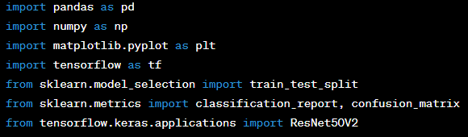

1. **Load the Model**

In this seminar work, we demonstrate a reliable deep learning-based technique for classifying coffee beans. Use a pre-trained ResNet-50V2 model, which is well-known for its powerful feature extraction skills, as a key part of our strategy. We considerably improve our model's capacity to correctly classify various coffee bean varieties by optimizing it for our particular goal of coffee bean classification.

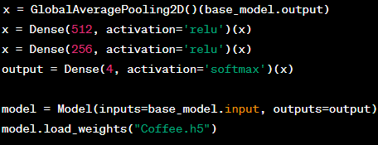

V. RESULT

The algoritham used in this system is ResNet that provides

accuracy.



The model's effectiveness is determined by how accurately it performs its task. In this case, it achieved an accuracy rate of 97% when tested with the dataset. This high level of accuracy demonstrates that the model is proficient in the task of grading coffee beans, as it correctly categorizes them

with a higher degree of precision. 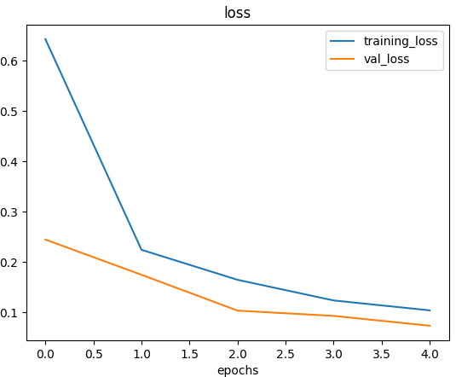

The graph illustrates the loss over epochs. The model exhibits a consistent decrease in loss as the training progresses, indicating successful learning.

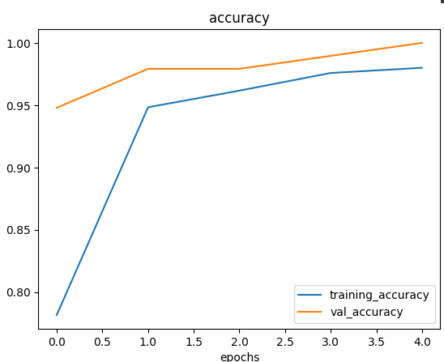

This graph showcases the model's accuracy improvements over epochs. It demonstrates a consistent rise in accuracy during the training process, indicating the model's improving capability to grade coffee beans more accurately as it progresses.

As part of our research, I have developed a web-based platform that empowers you to explore the world of coffee beans. Our interactive application allows you to upload an image of a coffee bean, and it will swiftly classify the bean based on its roast level.

Upload and Classify

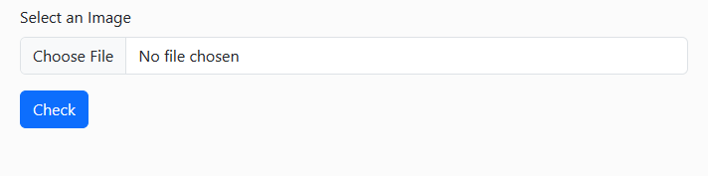

The output of the prediction is :

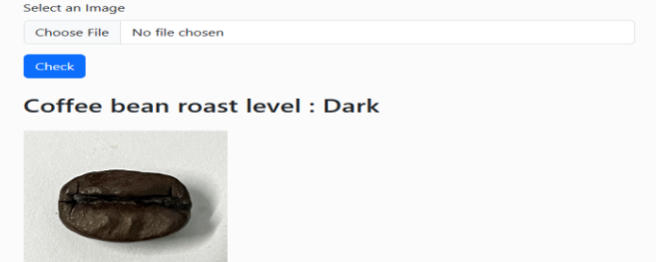

Fig. 3 predict the roast level

VI. CONCLUSION

In conclusion, the application of ResNet-based methods for coffee bean classification represents a powerful and promising approach in the realm of deep learning and image processing.

This approach offers a cost-effective and viable solution for accurately categorizing the roast levels of coffee beans, addressing a prevalent demand. The effectiveness of the ResNet-50 model has been shown to improve with preprocessing techniques like resizing images to 224x224 pixels and normalization.

To summarise, the ResNet-based strategy for coffee bean grading is an exciting field of study that may advance the development of future techniques for grading coffee beans that are more precise and effective.

##### VII. REFERENCES

[1] J. U. B. Aggenstoss, L. U. P. Oisson, R. U. T. H. K. Aegi,

R. A. P. Erren, and F. E. E. Scher, ―Coffee Roasting and

Aroma Formation : Application of Different Time -

Temperature Conditions,‖ J. Agric. Food Chem. 2008, vol.

56, pp. 5836–5846, 2008

[2] [Jokanović R. Marija](https://www.researchgate.net/scientific-contributions/Jokanovic-Marija-2074439508?_tp=eyJjb250ZXh0Ijp7ImZpcnN0UGFnZSI6InB1YmxpY2F0aW9uIiwicGFnZSI6InB1YmxpY2F0aW9uIn19),[Džinić R. Natalija](https://www.researchgate.net/scientific-contributions/Dzinic-Natalija-2074403638),[Biljana Cvetković](https://www.researchgate.net/profile/Biljana-Cvetkovic-4?_tp=eyJjb250ZXh0Ijp7ImZpcnN0UGFnZSI6InB1YmxpY2F0aW9uIiwicGFnZSI6InB1YmxpY2F0aW9uIn19)

[Grujic,Slavica](https://www.researchgate.net/profile/Grujic-Slavica?_tp=eyJjb250ZXh0Ijp7ImZpcnN0UGFnZSI6InB1YmxpY2F0aW9uIiwicGFnZSI6InB1YmxpY2F0aW9uIn19),[Odžaković Božana](https://www.researchgate.net/profile/Odzakovic-Bozana-2?_tp=eyJjb250ZXh0Ijp7ImZpcnN0UGFnZSI6InB1YmxpY2F0aW9uIiwicGFnZSI6InB1YmxpY2F0aW9uIn19)(2012) “Changes of physical properties of coffee beans during roasting”.

[3] Zhang, K., Zhang, J., & Zhang, L. (2022). Automated coffee bean defect detection using deep learning. IEEE Access, 10, 49674-49683.

[4] Chang, S. J. (2021). "Deep Learning Model for the Inspection of

Coffee Bean Defects."

[5] [Nelly Oktavia Adiwijaya](https://www.researchgate.net/profile/Nelly-Oktavia-Adiwijaya?_tp=eyJjb250ZXh0Ijp7ImZpcnN0UGFnZSI6InB1YmxpY2F0aW9uIiwicGFnZSI6InB1YmxpY2F0aW9uIn19) [Universitas Jember](https://www.researchgate.net/institution/Universitas_Jember) (2022)”The quality of coffee bean classification systembased on color by using k-nearest neighbor method”.

# T H Nasution and U Andayani (2017), Recognition of Roasted Coffee Bean Levels using Image Processing and Neural Network

1. Muhammad Aji Alrasyid(2023),"ResNet-50 to classify the types of Indonesian local coffee beans"

[8] [Pragathi S P](https://ieeexplore.ieee.org/author/37089783070), Christ Deemed to be University, Puneand [Lija Jacob](https://ieeexplore.ieee.org/author/37089455570)Department of Data Science, Christ Deemed To be University, Pune(2023), ”Review On Image based Coffee Bean Quality Classification: Machine Learning Approach”

Fig .2 Uploading coffee bean image